Portfolio Website

# Introduction

I had a larger idea that would span all 4 courses, but I think I’m going to save it for the react courses instead. So I decided to update my portfolio site with a basic layout and some bootstrap classes for this course. A portfolio site is a good way for recruiters to get samples of my work and get in touch with me for future projects.

# Design and Implementation

## Design

The main idea for the site is to have a plain color bar on the left side with navigation elements to the core sections on the page. All of the pictures below will be one long scrolling body of content.

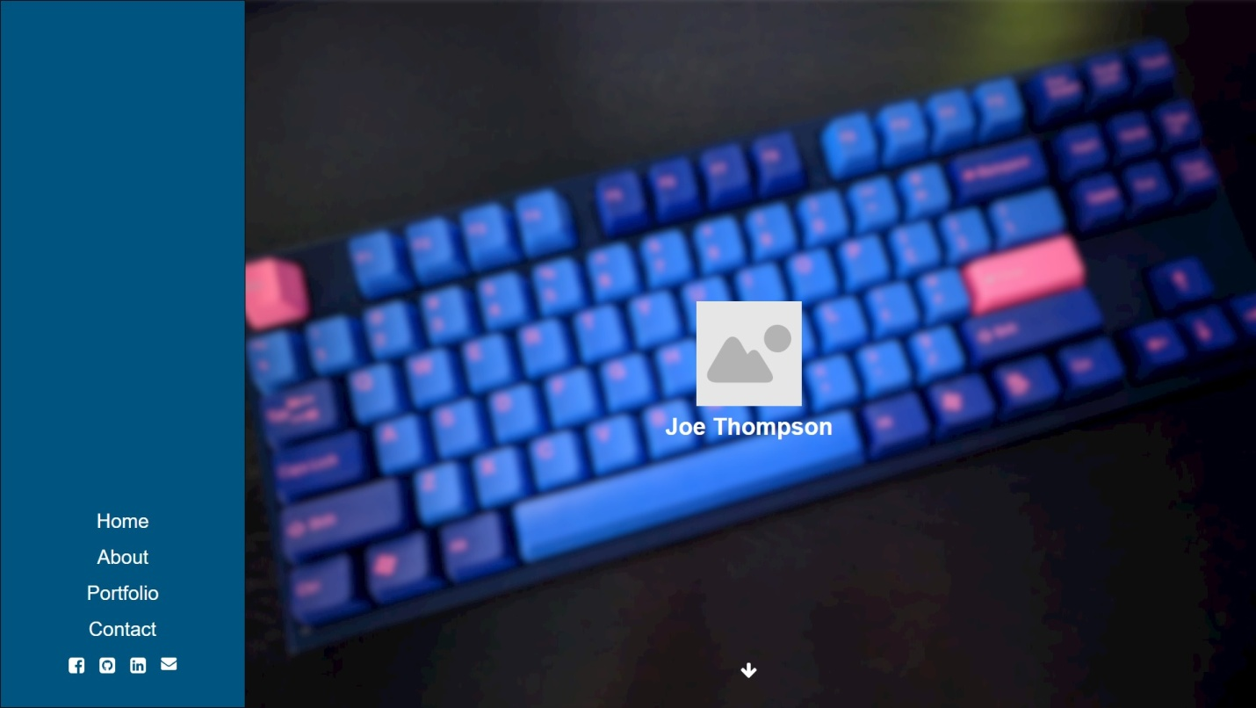

The home page will have a large background image, an image of myself, and my name. Simple and clean with some sort of symbol/down arrow to indicate that the user should scroll down for more info.

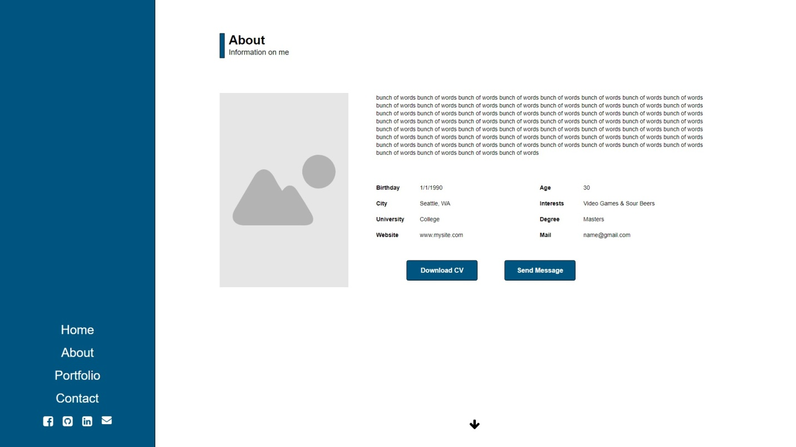

The next section is the about section where I’ll include another picture, some text about myself, and some information about myself. The link to download CV will download my resume and the send message button will link to the “contact” section.

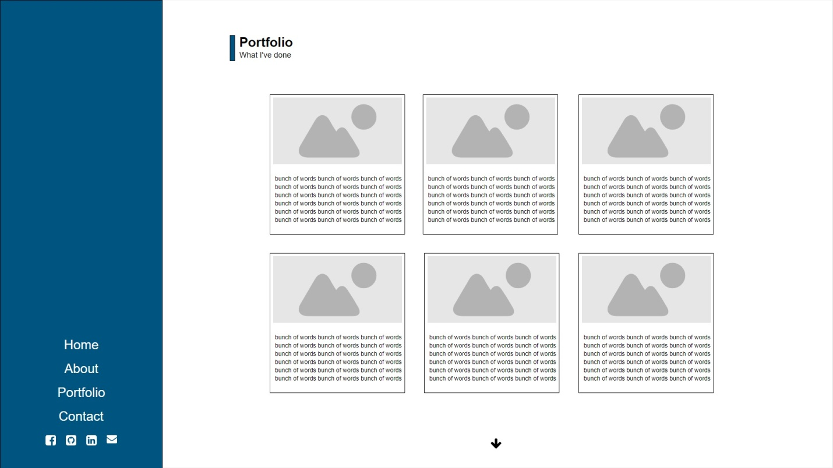

For the portfolio I’ll use a list of cards with images and text. I’m hoping these can be different heights with grid layouts so they’ll create more of a puzzle than the very structured example I have above.

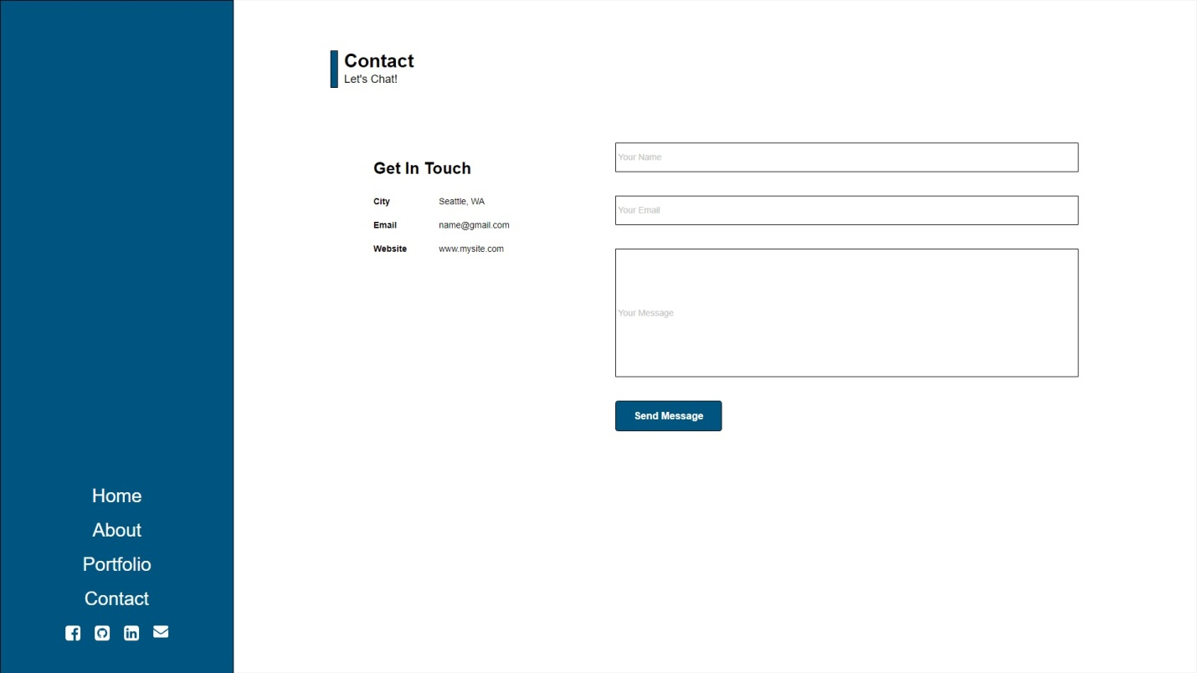

At the bottom of the scrolling page is the contact section, basic input for name, email, and message with a send message button. I’ll remind the reader about my contact information in case they want to reach out to me in a different way.

## Implementation

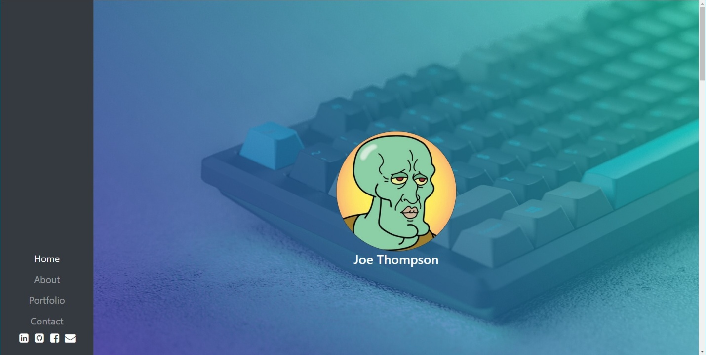

I started by implementing the left-side navbar and initial background image. Bootstrap does not support a left-aligned navbar by default, which surprised me since so many people use it in their portfolio sites. After looking around, I decided to use “bootstrap-navbar-sidebar”, which extended the Bootstrap NavBar element and simply modified the css to provide the look I was going for. The only difficult part was figuring out how to use a flexbox in order to have the navigation elements at the bottom of the left-navbar. Once that was set, I added links and IDs for each section to get the left navbar functional.

I had a lot of issues setting up a background image behind my profile pic and name. I ended up following a tutorial (see references), which is also where I learned about masks and applying gradient colors to images, which turned out really nice. There’s still some issues with the background being as responsive as I’d like, but for the purpose of this project I think it works.

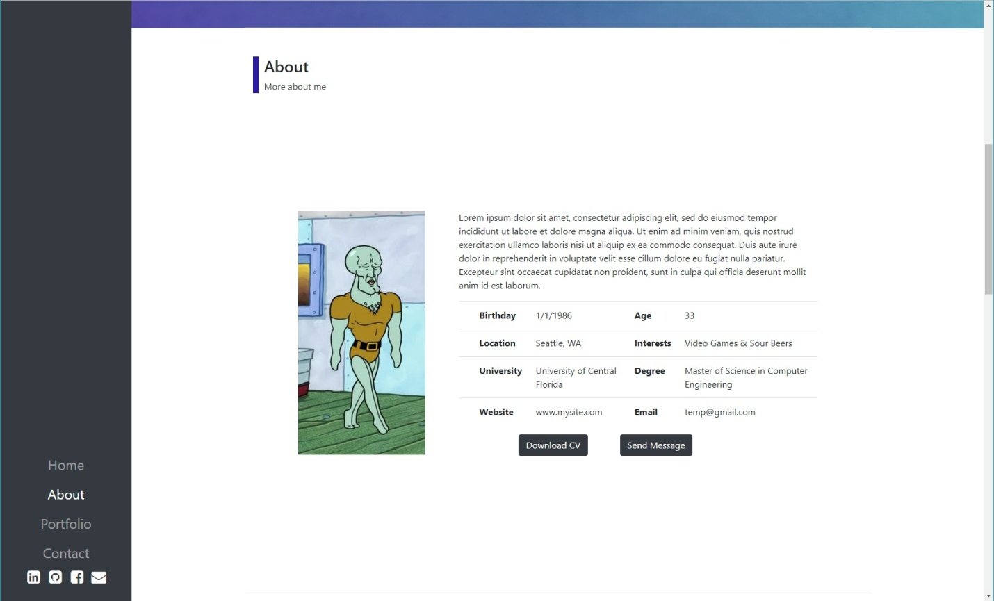

Scrolling down, the about page came together pretty quickly. A simple grid layout with offset-md-1, col-md-3 for the image, and col-md-7 for all the text fit very nicely. I used a table for the information and decided to leave the default settings since the lines looked nice. The download CV button links to a pdf file I have stored with my resume and the send message scrolls to the contact section using the ID “ContactSection”.

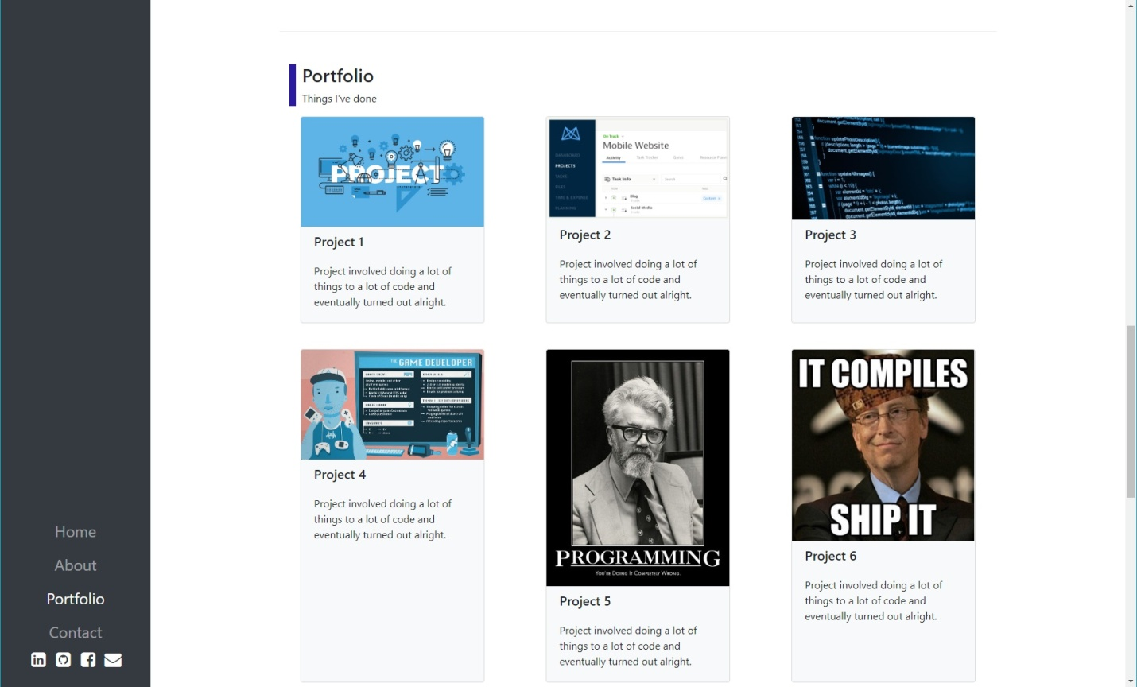

Scrolling down, the portfolio section took the longest amount of time. Creating the individual cards was simple with card, card-image-top, card-title, and card-body classes, but the default styling looked terrible. I tried to add padding and margins with 3 col-md-4 wide cards per row, but that broke the grid layout and I only ended up with 2 cards/row. I gave up and eventually went with offset-md-1/col-md-3 width for each card in order to get 3 per row and a decent spacing between them. I also wanted the cards to be the min height needed to fit the content (example, project 4 card is way too tall since it matches the size of project 5). If cards were only the height they needed to be, the cards could intertwine vertically to give a much more natural feel. Bootstrap does not support this and tutorials to create that kind of layout were very complex, so I ended up leaving the cards in Bootstrap classes for now. The limitation here is that images and text need to be balanced so one card doesn’t become much larger from other cards in the row.

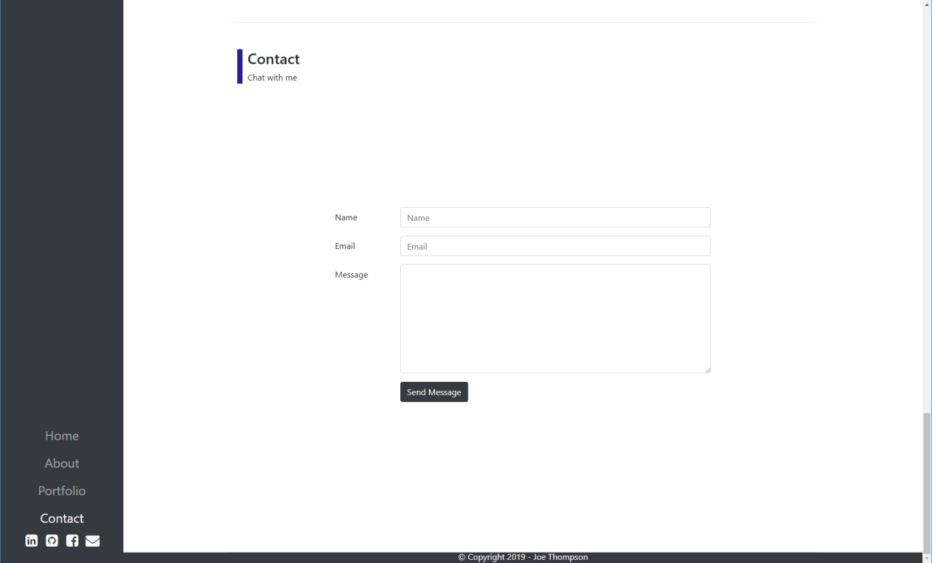

The contact section was a simple copy/paste from the project and minimizing the amount of options to fit a simple portfolio page compared to a restaurant.

The one other Bootstrap class that I utilized was the scrollspy. This allowed the list of links in the NavBar to change active toggling as the user scrolls down the page from one section to the next. I had to restructure my divs and ended up wrapping the majority of the site in a separate div for the scrollspy, but eventually was able to get it working. The example on the Bootstrap page is too simple to figure out on a real webpage, so I turned to stackoverflow and tutorials for more real world examples of how to use the scrollspy.

# Conclusions

This project was a great first implementation of using Bootstrap from scratch to quickly stand up a new website. Using moqups as a design site was super easy for creating a simple layout and I had a good idea of which Bootstrap components I wanted to use right away for each section.

Most of the features that I wanted for this project I was able to implement with Bootstrap classes directly. The left NavBar for navigation and updating the active link using scrollspy took a lot of attempts, but it came out great! The site features work and the site looks nice, but it’s really missing the final level of polish that makes a website stand out from the rest. Bootstrap applies so many layers of styling, I found it very difficult to modify and stuck with the defaults, which looks like powerpoint for websites and is a little disappointing. The only part that looks near complete is the Home section, which is from a tutorial I followed that didn’t use Bootstrap…

Sections that matched the Bootstrap default styling (tables, headers, navbar, forms, buttons) were very easy to use and created nice looking components. Trying to modify the Bootstrap defaults to fit a different style (what I wanted to do with the cards) is near impossible. The Bootstrap default for cards didn’t look good and I had to override a lot of css to make my cards look as nice as the cards on the Bootstrap documentation site. Bootstrap also felt very limiting in the vertical direction. The horizontal grid is great to work with, but centering items vertically and modifying the height of items took lots and lots of attempts to get components correctly aligned.

Going forward, I think I’ll continue to use Bootstrap for putting together quick prototypes and reviewing concepts with other team members, but I would need to learn a LOT more about styling Bootstrap classes to ever make a legit website. I’m hoping React provides more options in the next class!

# References

* <https://mladenplavsic.github.io/bootstrap-navbar-sidebar/>
* <https://mdbootstrap.com/docs/jquery/css/background-image/>
* <https://getbootstrap.com/docs/4.0/components/card/>
* <https://getbootstrap.com/docs/4.0/components/scrollspy/>